Relation Between High Pressure Blocking and Aerosol Concentrations in Southern Sweden
Fredrik Bergelv
Moa Sporre PM_{2.5}
Department of Combustion Physics, Lund University, Sweden
July 23, 2025

Abstract
High-pressure blocking events are anticyclones that persist over a region for a long time. The event prevents vertical mixing of air pollutants due to the subsidence inversion created by the adiabatic compression of air in the anticyclone. This study investigates the relationship of aerosol concentrations during periods of high-pressure blocking events in southern Sweden for the rural location of Vavihill and the urban location of Malmö. A total of 208 highpressure blocking events were identified in Vavihill and Malmö between 1995 and 2024. The requirements for a high-pressure blocking event were: A pressure above 1014 hPa, the event lasting for at least 5 days, having a maximum amount of rainfall of 0.5 mm h−1, and an accumulative amount of rainfall of less than 5 mm for the entire event. These criteria had to be fulfilled for the initial five days in both locations with a maximum time difference of 5 h. The PM2.5 levels during the progression of the high-pressure blocking events were compared to mean PM2.5 concentrations from the same location. The data was also sorted according to wind direction, season, and pressure strength for further analysis. Moreover, to determine whether the frequency of high-pressure blocking events is changing, meteorological data from southern Sweden between 1946 and 2024 was analysed. Using Mann-Kendall statistics and standard deviations, the data showed a significant increase of PM2.5 for both locations during periods of high-pressure blocking. In general, PM2.5 concentrations were higher in Malmö than in Vavihill due to more local emissions. Peak aerosol levels were achieved eight to thirteen days after the start of the high pressure blocking event, indicating an accumulation of aerosols during the event in both locations. The investigation showed a stronger increase with winds from eastern and central Europe, indicating advective transport of aerosols to the region. Local emissions most likely also played a role in the increasing PM2.5 levels. This was supported by the findings of the seasonal and pressure strength dependencies, where stronger high-pressure blocking events showed the highest the strongest increase in PM2.5 in particular in Malmö. No long-term increase in the frequency of highpressure blocking events was found in the region. The results from this study show how aerosol concentrations and air-quality is highly dependent on atmospheric events in the region.

Keywords: Aerosols, PM2.5, high-pressure blocking, Mann-Kendall, southern Sweden, Skåne

1 Introduction
It is common knowledge that Earth’s increasing temperature has many side effects. One such effect is the increase in frequency of extreme weather phenomena (Mitchell et al. 2006). One such phenomenon, which lacks extensive research, is high-pressure blocking events. A high-pressure blocking event is an anticyclone that covers an area for a prolonged period of time and often blocks other types of weather, hence the name. This results in limited cloud formations and a pronounced daily temperature variation (Lupo 2020). However, an anticyclone is also associated with slower air movement, causing the air to remain stagnant. This can lead to an accumulation of air pollutants such as aerosols (Cai et al. 2020).
Anticyclones are meteorological high-pressure systems in which air sinks toward the ground, creating high pressure (Spiridonov and Mladjen 2020). The descending air undergoes adiabatic compression, resulting in an increase in air temperature. This temperature increase inhibits cloud formation, as warmer air can hold more moisture. The absence of clouds this leads to a large temperature difference between day and night, with summer anticyclones being associated with high temperatures and winter anticyclones with low temperatures. Due to the Coriolis force the winds during anticyclones rotate in the clockwise direction in the Northern Hemisphere.
A high-pressure blocking period refers to a prolonged anticyclone characterized by higher surface pressure covering a large area (Lupo 2020). Since blocking events extends over a vast region, the pressure gradient remains small due to minimal pressure fluctuations. As a result, the wind tends to be calm. A blocking period is typically defined as lasting between five and ten days, although some events can persist even longer (Por˛ebska and Zdunek 2013). However, no single definition of high-pressure blocking events exists (Lupo 2020). High-pressure blocking event are often followed by rainfall and or a strong shift in wind direction. Lupo 2020 showed that the frequency of high-pressure blocking periods has increased in the Northern Hemisphere, including Europe, during the last 50 years. Luo, Yao, and Dai 2015 has shown how high-pressure blocking events has became more common in eastern Europe during 1978 to 1994, and more common in western Europe during 1995 to 2001. Fahimi et al. 2020 showed that although high-pressure blocking events decreased between 1959 to 1988, they increased from 1989 to 2011.
Recurring anticyclones can be classified into Hess and Brezowsky macrocirculation types. Three such anticyclones that often impact the weather in Scandinavia is the Fennoscandian High (HFA), the Southeast Anticyclone (SEA), and the Central European High (HM) (Bartholy, Pongracz, and Pattantyús-Ábrahám 2006). HFA is centred on the Fennoscandinavian Peninsula (Norway, Sweden, Finland, and western parts of Russia) and is a recurring anticyclone during the winter. This anticyclone is known for blocking air masses from the Atlantic, causing colder periods in the region. The SEA is a recurring anticyclone with its geographical center in southeastern Europe (the Balkans and western Türkiye). This anticyclone is most frequent during the summer months and is associated with heat waves. The HM is centred in central Europe (Germany, Poland, the Czech Republic) and occurs during both the summer and winter months. The center of these anticyclones can be seen in Figure 1.
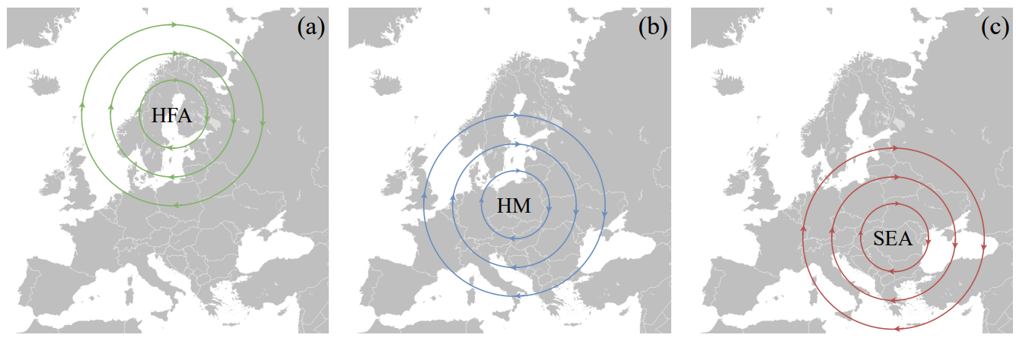
Figure 1: These maps show the air movement during the HFA, HM, and SEA blocking events (Sigler, Marian 2007). The figures only show the general streamlines of the Brezowsky macrocirculation types, meaning that the real world anticyclones would not be perfectly circular
During an anticyclone, adiabatic compression of the air occurs as the air descends. This increases the temperature at lower altitudes. However, this downward movement of air does not reach the ground due to the friction opposed by buildings, forests, valleys, and other obstacles that create friction by disrupting the airflow (Lautrup 2011). Thus, the downward draught will spread out a few hundred meters above the ground and not mix with the air that lies closest to the ground. Since the air closest to the ground remains cool, while the air a few hundred meters up is warmer from the adiabatic compression, an inversion of the environmental lapse rate will be created. This is called a subsidence inversion and will prevent air mixing between the ground level and the upper layers of the atmosphere (Gramsch et al. 2014). The absence of clouds during the anticyclone also promotes ground inversions during night-time. Outgoing radiation from the Earth cases a strong cooling of the surface which in turn cool the air closest to the ground. This creates a ground inversion layer, where the air temperature increases with height in the lowest atmospheric layers (Greg O’Hare, Rob Wilby, and John Sweeney and Rob Wilby 2005). Crétat et al. 2024 has shown that the topography and imperviousness of the surrounding area has a large influence on the thermal inversion of the location. Urban locations are linked to stronger thermal inversions due to impervious surfaces and reduced air circulation, whereas forested areas typically have weaker inversions because of canopy shading and enhanced air mixing. This ground inversion also prohibits vertical air movement in the atmosphere.
Aerosol particles can substantially impact both climate and human health. Aerosol particles have a range of sources and have lifetimes in the troposphere of approximately a week. This means that they can be transported from region to region and from one country to another. Aerosol particles comes in a range of sizes from a few nanometres up to several micrometers. When dealing with aerosols it is important to specify which types of particles are being measured, where PM2.5 (particulate matter with an aerodynamic diameter of 2.5 µm or less) is a common choice because PM2.5 is easy to measure. Although aerosols can form naturally in the atmosphere, the primary sources in urban and suburban Europe include solid fuel combustion for domestic heating, industrial activities, and road transportation (European Environment Agency 2024). Particulate contributors to PM2.5 include sulphur dioxide (SO2) and soot (black carbon), both originating from the burning of fossil fuels. The European Union set an annual mean limit for PM2.5 concentrations at 25 µg m−3 in 2008, although the WHO suggested a much lower threshold of only 5 µg m−3 (European Environment Agency 2024). In 2022, the EU mean limit threshold was exceeded in several European countries, including Croatia, Bosnia and Herzegovina, Italy, Poland, North Macedonia, and Türkiye (European Environment Agency 2024).
Studies have demonstrated a correlation between elevated PM2.5 concentrations and an increased risk of respiratory, cardiovascular, and cerebrovascular diseases, as well as diabetes (Sharma, Chandra, and Kota 2020). Hvidtfeldt et al. 2019 showed, by studying on 49 564 individuals in Denmark between 1993 and 2015, that every 5 µg m−3 increase in aerosol concentrations increases the hazard ratio by 1.29. Thus, for every 5 µg m−3 increase in PM2.5 the risk of dying from cardiovascular diseases increased by 29%. Further studies on PM10, which is closely related to PM2.5, showed that in the age group of 75-84 mortality increased 36% and 106% in the age group 85+ during heath waves associated with high PM10 concentrations (Analitis et al. 2014).
During a high-pressure blocking event the environmental lapse inversion, especially the subsidence inversion, prohibits vertical air mixing in the atmospheric layers closest to the ground. If aerosols are produced at ground level during this high-pressure blocking event, this would imply that the aerosols would not disperse vertically, implying a higher concentration on the ground level. Thus, one would expect higher concentrations of PM2.5 during high-pressure blocking events. Different studies, such as Dempsey 2018 in Ontario, Canada; Messori et al. 2018 in Europe; Shin et al. 2021 in Seoul, Korea; and Özdemir, Birinci, and Deniz 2024 in Istanbul, Türkiye, have all correlated regional high-pressure blocking events with increased concentrations of PM2.5. The reason for the increases include less vertical dispersion of aerosols during the events, stagnant air conditions, and shifted air movements.
Since aerosol emissions are particularly high in central European countries such as Poland, anticyclonic winds from the south and east from HFA, SEA, and HM are expected to increase PM2.5 concentrations in southern Sweden (European Environment Agency 2024). These aerosols would be transported to southern Sweden via southerly to easterly winds during the anticyclone, as seen in Figure 1. If this occurs during a high-pressure blocking event, the aerosols may accumulate over the region while continuously being advected by southerly and easterly winds.
In this study we investigate how the concentrations of aerosol particles change during high-pressure blocking events in southern Sweden. We have used meteorological data from the Swedish Meteorological and hydrological institute (SMHI) to determine periods of high-pressure blocking events and analysed the PM2.5 levels in a rural (Vavihill, Svalöv, Skåne County) and an urban (Malmö, Skåne County) location during the high-pressure blockings. We have used wind direction, season, and pressure strength to gain a comprehensive understanding of how PM2.5 levels change under different types of high-pressure blocking events. In this study we sill also explore the longterm frequency of high-pressure blocking events to determine whether this weather phenomenon is becoming more common, which is particularly important if a positive correlation with aerosol levels is found.

2 Method

2.1 The Data Handling and Devices
The meteorological data was downloaded from the SMHI’s website. The data included hourly atmospheric pressure data, hourly rain data, and hourly wind data (speed and direction). Hourly aerosol data as PM2.5, measured over one-hour intervals, was also downloaded. Since the purpose of this thesis was to analyse aerosol concentrations in southern Sweden during high-pressure blocking events, one urban and one rural site were selected. The locations were chosen based on their classification as rural or urban and the length of time the stations had been in operation, where more data was considered better

2.1.1 The Aerosol Data and Measurements
The rural measuring station in the county of Skåne with the most aerosol data was Vavihill located in Svalöv, southern Sweden. This station was active from September 28, 1999, to November 15, 2017. However, due to missing data on some days, only 57% of the period contained non-missing values. Additionally, between 2017 and 2018, the Vavihill station was relocated to nearby Hallahus, where we have acquired data from May 10, 2018, to December 31, 2022, with 93% of the period containing non-missing values. Combining these datasets resulted in a total of 5371 days of hourly data. For an urban location in the county of Skåne, Malmö Rådhuset had the most data, with measurements recorded from June 3, 1999, to December 31, 2023. Here, 90% of the recorded values were non-missing, resulting in 8074 days of data. The geographical location of the two locations, together with pictures showing the surrounding area, can be seen in Figure 2.
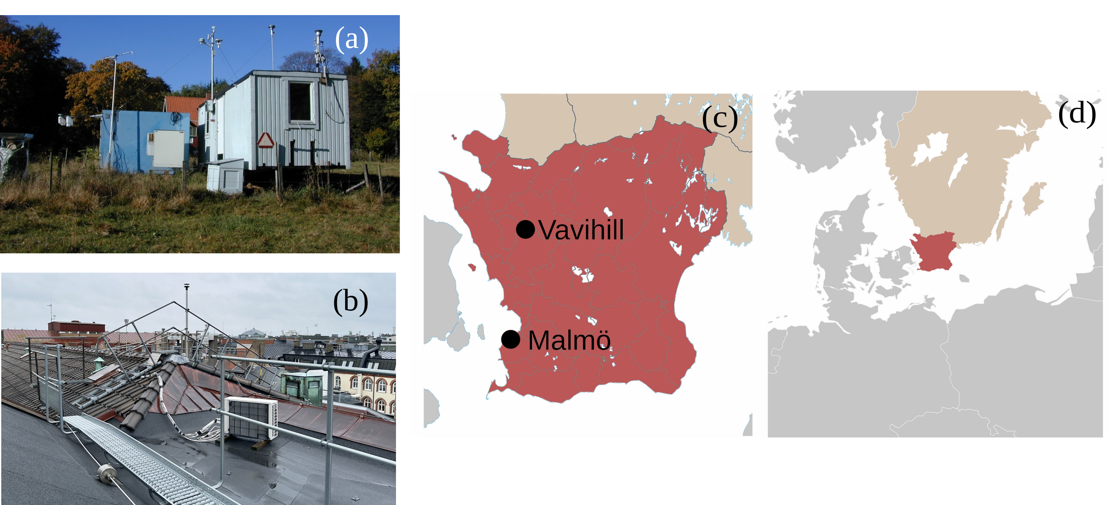
Figure 2: Pictures showing (a) the measuring station in Vavihill, (b) the measuring station in Malmö taken by Sellergren 2025, and (c) and (d) a map displaying the geographical locations (E. Frohne 2009 and Region Skåne 2025).
The measurement device used at Vavihill was the ambient particulate monitor TEOM 1400. The precision of the monitor was ±1.5µgm−3 . When the measuring station was moved to Hallahus, the measuring device was updated to the fine dust analysis system Palas FIDAS 200. This results in a high accuracy of ±0.1µgm−3 . The monitoring station in Malmö used several measuring devices over time, in conjunction with other equipment. Between the start of the monitoring and January 1, 2009, the TEOM 1400 monitor was used. From January 1, 2009, to December 31, 2015, the TEOM 1400, FDMS, and 8500 B or CB dryer were employed. Between January 1, 2016, and December 31, 2021, the TEOM 1405F and FDMS systems, along with the 8500 B, were in use. Finally, from January 1, 2022, the Palas FIDAS 200 monitor replaced the earlier systems.

2.1.2 The Meteorological Data and Measurements
The meteorological data which was used in this thesis can be observed in Table 1. The time periods listed in the table show which periods was used this study, which may not represent the full operational range of the stations. Overall, the choice of meteorological data was based on the proximity to the PM2.5 measuring stations in the case for Vavihill and Malmö and on the availability of data covering as much of the PM2.5 measurements as possible. For Vavihill, there were no meteorological data nearby the station. The pressure data used for Vavihill was from Helsingborg 25 km away. However, Helsingborg is a coastal city and can experience daily cycles of sea breezes and land breezes and we therefore choose rain and wind data from Hörby which is situated more inland. For Malmö, both wind and rain data from the city are used but the pressure data was not available from this measurement station for the entire PM2.5 measurements period. We therefore used pressure data from Helsingborg also for the PM2.5 measurements from Malmö. During high-pressure blocking events there are very small variations in pressure, winds and only very little precipitation and using meteorological data from stations some distance away should not be an issue. E.g. during the period from December 1, 1995, to October 1, 2024, the mean difference in pressure between Ängelholm and Helsingborg was (0.25 ± 0.20)hPa, indicating a very small difference. For the analysis of whether high pressure blocking have become more common we wanted as long time series as possible. We therefore used data from Ängelholm airport which has hourly pressure measurements from 1946. Rain data from Ängelhom airport was used in conjugation with the nearby location of Tånga. This was used since the rain data from Ängelholm did not cover the entire period, whereas Tånga covered the remaining part.
Table 1: The meteorological data for each location.
 |  | Vavihill | Malmö | Ängelholm
Air Pressure | Station | Helsingborg (25 km away from particle monitor) | Helsingborg (49 km away from particle monitor) | Ängelholm airport
 | Period | August 2, 1995 to October 10, 2024. | August 2, 1995 to October 10, 2024. | January 5, 1946 to October 1, 2024
 | Device | Vaisala PTB220 (April 15, 2015, to April 17, 2025, and from September 19, 2004, to May 23, 2014) PTB201A (Remaining time) | Vaisala PTB220 (April 15, 2015, to April 17, 2025, and from September 19, 2004, to May 23, 2014) PTB201A (Remaining time) | No info
Wind | Station | Hörby (35 km away from particle monitor) | Malmö (6 km away from particle monitor) | Ängelholm airport
 | Period | August 1, 1995, to October 1, 2020. | January 1, 1990, to December 31 2020. | January 5, 1946, to July 31 2024.
 | Device | Vaisala WAA15A (speed) Vaisala WAV15A (direction) | Vaisala WAA15A (speed) Vaisala WAV15A (direction) | No info
Rain | Station | Hörby (35 km away from particle monitor) | Malmö (6 km away from particle monitor) | Ängelholm and Tånga.
 | Period | August 1, 1995, to October 1, 2020. | November 21, 1995, to December 31 2020. | January 18, 1947, to November 30, 2001 and December 19, 1973 to August 31, 2024.
 | Device | Geonor T200 | Geonor T200 | No info and beaker.

2.2 The Identification of High-Pressure Blocking Events
To evaluate the occurrence of high-pressure blocking event for Vavihill or Malmö, the rain data and atmospheric air pressure were used, which can be seen in Figure 3. For a period to be defined as a high-pressure event, the atmospheric pressure had to be over 1014 hPa, the rainfall had to be less than 0.5 mm h−1 and the entire event had a maximum amount of accumulative rainfall of 5 mm. These values were based on the fact that 1014 hPa was the mean atmospheric pressure from Helsingborg, and 0.5 mm h−1 was chosen since this is considered as very light rain. To ensure that the event did not consist of very light rain for a prolonged period, the accumulative event limit of 5 mm was used in conjunction with the 0.5 mm h−1 limit. Since a high-pressure blocking event covers a large geographical area, and Vavihill and Malmö are located close to each other, a blocking event observed at one location should also be detectable at the other. To account for this, all identified high-pressure blocking events at one location were required to correspond to an event at the other location within a maximum time difference of 5 h. 7 However since Vavihill and Malmö used the same air pressure measuring station, this meant that the precipitation in both locations had to be under 0.5 mm h−1 and 5 mm for the event. For a high-pressure event to be considered a high-pressure blocking event, the criteria for a high-pressure event had to persist for at least 120 h (5 days). This value was chosen since a 5-day limit is often considered when classifying high-pressure blocking events (Lupo 2020).
The rain-limit was set to 1 mm d−1 in Ängelholm since daily precipitation measured used instead. This value was chosen since it corresponds to a small amount of rainfall for a day, and almost no rainfall should be observed during high-pressure blocking events. The choice of 0.5 mm h−1 for hourly data is motivated by the fact that continuous light rain over a 24-hour period is very rare. As a result, daily precipitation levels seldom reach 12 mm d−1, and are more commonly around 1 mm d−1. The accumulative rain limit of 5 mm for the entire event was not needed here since this value was never reached.
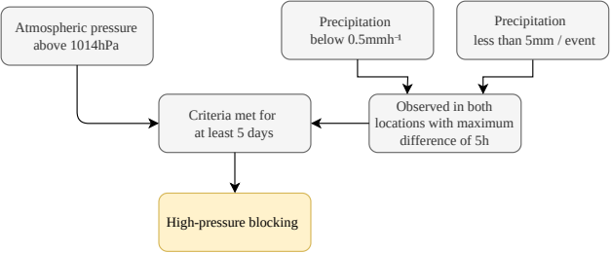
Figure 3: This figure show how a high-pressure blocking events was defined in Vavihill and Malmö

2.3 Statistical Evaluation: The Mann-Kendall Test and Sen’s Slope
To evaluate statistical significance of the trends found in the study, the statistical Mann-Kendall test was used. The Mann-Kendall test was applied to evaluate whether the PM2.5 mean during high-pressure blocking events had increased, and if so, by how much. The Mann-Kendall test is a non-parametric statistical test used to calculate the monotonic trend and the significance of the result of a dataset. This test is commonly used in climate physics due to the challenges posed by many parameters and complex distributions. The test works by calculating the difference between each time step in the dataset. The output will be a p-value below 0.05 if the test provides a significant result, meaning that the trend is unlikely to be caused by randomness. Kendall’s τ-value is used to evaluate the monotonic increase of the dataset, where -1 indicates a total monotonic decrease, 1 indicates a total monotonic increase, and 0 indicates no monotonic trend. The τ-value can be summarized by the formula
$$τ=\frac{C−D}{C+D},$$ | (1)
where C is the number of concordant pairs and D is the number of discordant pairs. A Concordant pair is when two neighbouring data points increase with the time step, and discordant pair decreases with the time step. If the result yielded a τ-value above 0.5, the result was labelled as a clear increase.
Sen’s slope is a method, often used together with the Mann-Kendall test, of performing linear regression on the data. If a monotonic increase is shown by the Mann-Kendall τ, Sen’s slope provides an estimate of the magnitude of that increase. The method differs from the least squares method because it uses the median to calculate the slope. This ensures that outliers, which are common in weather data, do not affect the results. Sen’s slope is calculated as
$S_{i}=\frac{ρ_{\text{i+1}}−ρ_{i}}{t_{\text{i+1}}−t_{i}}$ Sen’s slope = median($S_{i}$), | (2)
where i represents the indices, ρ represents the concentration of PM2.5, and t represents time. The program used for the Mann-Kendall test was the pymannkendall package in Python (Hussain, Md. and Mahmud, Ishtiak 2019).

3 Results

3.1 The Change in Aerosol Concentrations
After applying the high-pressure blocking detection method to the data from Vavihill and Malmö for the entire period, a total of 208 high-pressure blocking events were identified between November 27, 1995 and September 22, 2024. For Vavihill 113 high-pressure blocking events of the original 208 were removed due to insufficient PM2.5 data, as a filter requiring 85% data coverage was applied. This left 95 relevant high-pressure blocking events. For Malmö 47 high-pressure blocking events were removed due to insufficient PM2.5 data, again applying the 85% data coverage filter. This resulted in 161 relevant high-pressure blocking events. An example plot showing periods of high-pressure blocking events can be seen in Figure 4. This figure provides insight into the categorization of high-pressure blocking events for the two different locations.

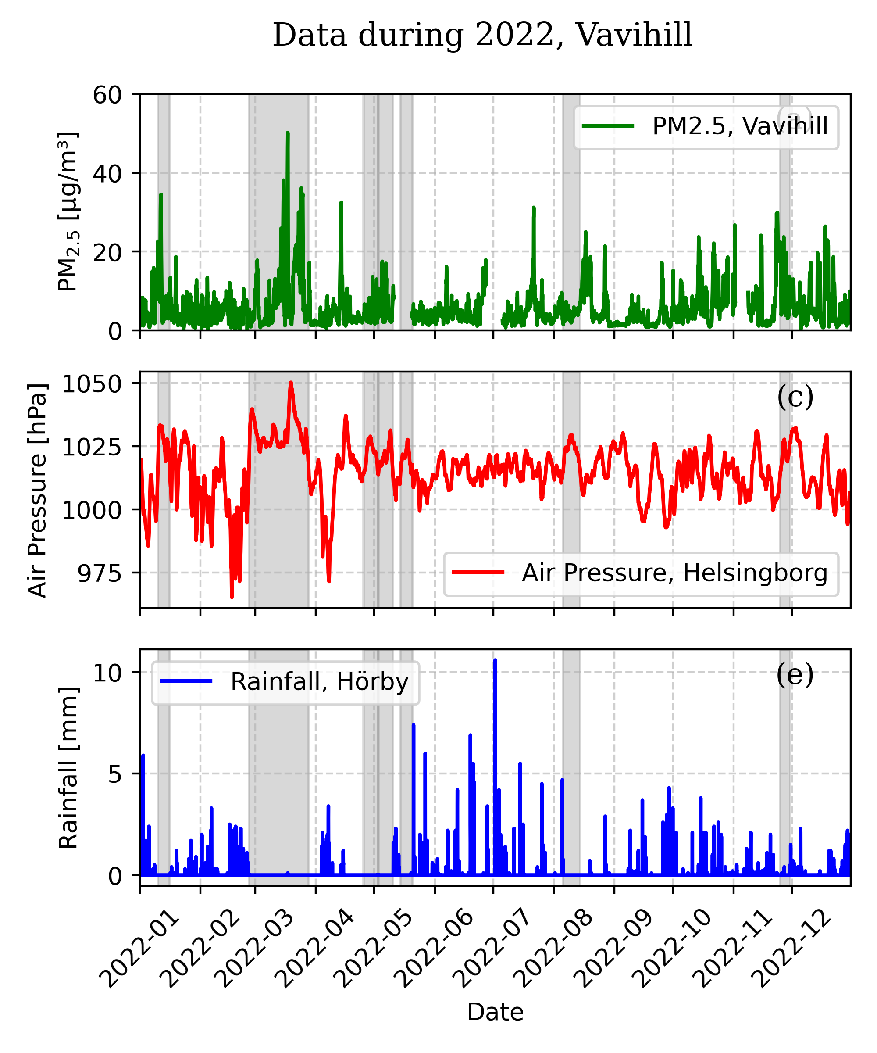 | 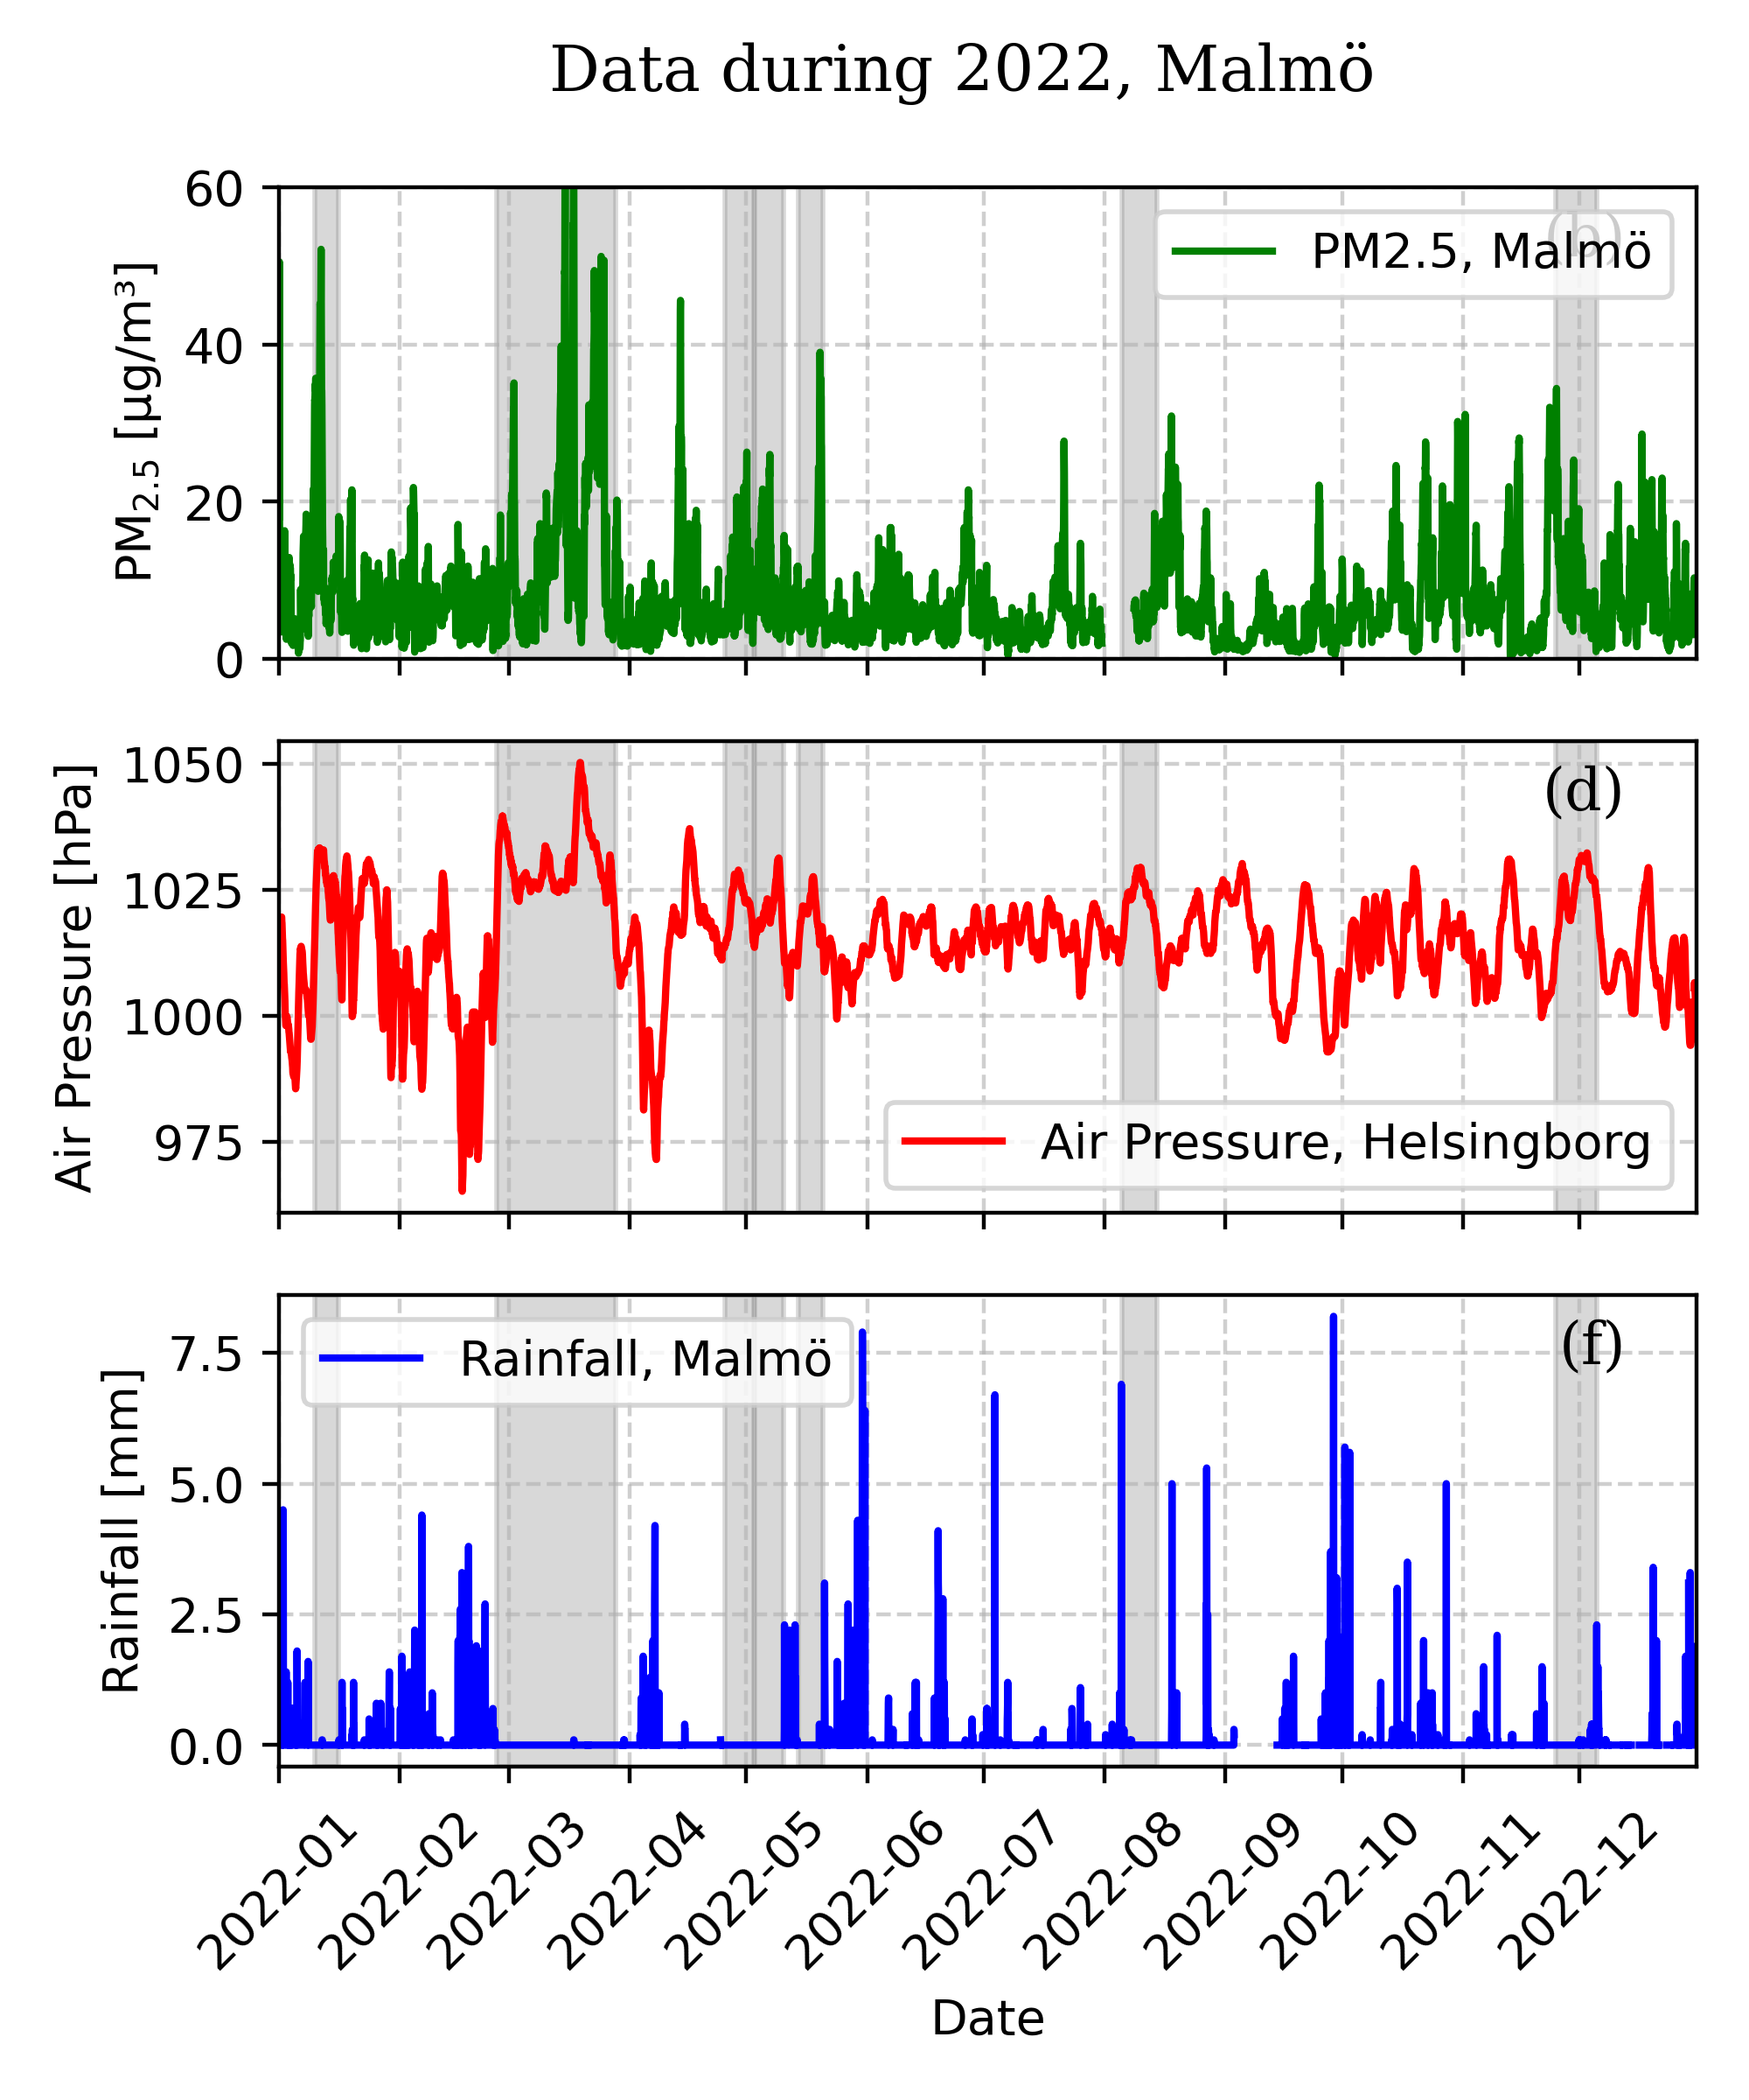
Figure 4: Example plots displaying the air pressure, PM2.5 concentrations, and rainfall during the year 2022. The periods which were indicated as periods of high-pressure blocking events are shaded in gray. This displays a normal yearly distribution of high-pressure blocking events using the described method.
To evaluate the progression of aerosols levels during the evolution of the high-pressure blocking events, the mean and standard deviation PM2.5 levels were calculated for all the high-pressure blocking events for each hour since the start of the events. Since the high-pressure blocking events varied in length the number of events that are included in the event decrease after day 5 (Figure 5), but a minimum of eight events was required when calculating the mean and standard deviation on the PM2.5 data. The mean PM2.5 value is compared with the mean PM2.5 value during periods without high-pressure blocking events, as well as with the EU annual mean limit for PM2.5.
The average change in PM2.5 concentrations during periods of high-pressure blocking can be seen in Figure 5. The data is compared with the PM2.5 mean taken from periods without high-pressure blocking events. An increase in PM2.5 concentrations can be seen in Malmö from 10 µg m−3 to a maximum of 21 µg m−3 at day thirteen, and an increase from 7 µg m−3 to a maximum of 18 µg m−3 at day twelve can be seen in Vavihill. The increase is supported by the large τ-value of τ = 0.78 in Malmö, and slightly lower τ = 0.70 in Vavihill. The Sen’s slope values also indicate a stronger increase in Malmö 3.0 × 10−2 µg m−3 d −1 compared to 2.1 × 10−2 µg m−3 d −1 in Vavihill.

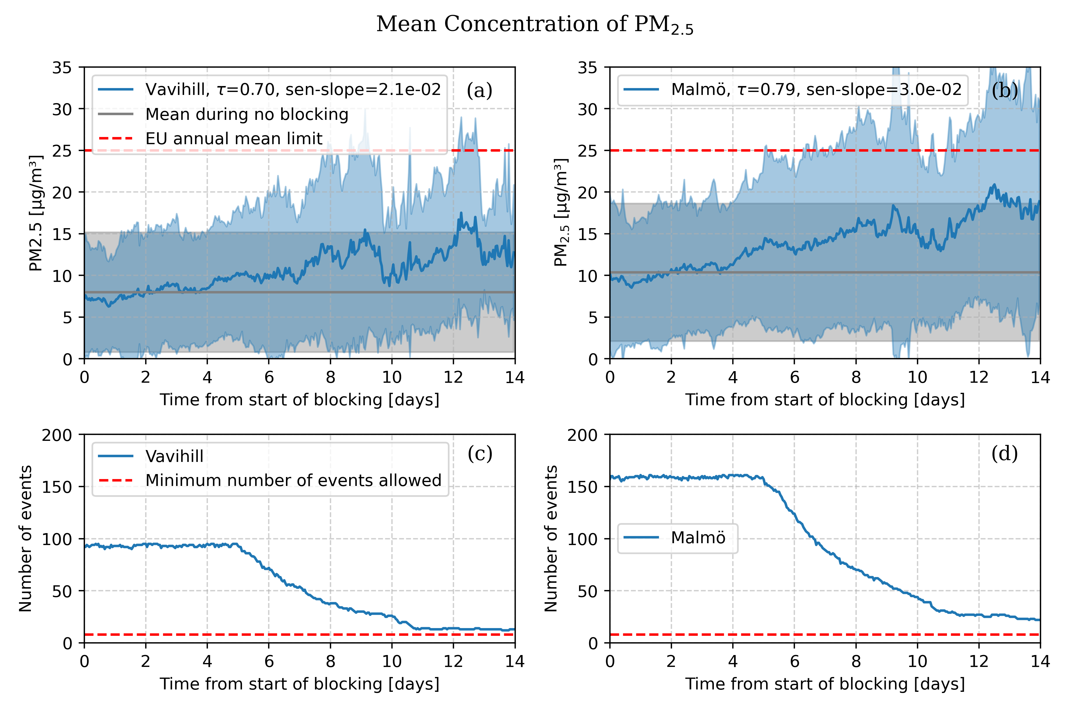
Figure 5: Mean PM2.5 concentrations in Vavihill (a) and Malmö (b) during high-pressure blocking events (blue line). The grey line shows the mean PM2.5 during non-high pressure blocking events. The shaded region indicates the standard deviation of the data. The number of high-pressure blocking events used in the analysis can be seen in (c) and (d), where the minimum number of events allowed was shown by the red line.
To investigate if the PM2.5 levels returned to normal after the end of the events, the mean and standard deviation of the PM2.5 were also calculated from the end of each high-pressure blocking event and onwards. In Figure 6 one can observe that after the end of the high-pressure blocking events, the PM2.5 levels often drop to levels close to the average during the first day after the end of the event. This is an interesting result which highlights that the increase observed in Figure 5, is indeed due to the presence of a high-pressure blocking event. This drop after the event is expected since high-pressure blocking events are often terminated by frontal or low-pressure systems that result in rainfall. The end of the blocking event is also often associated with a change of wind direction, increased wind speeds and a removal of the subsidence inversion. These factors together contribute to a fast decrease in aerosols concentrations.
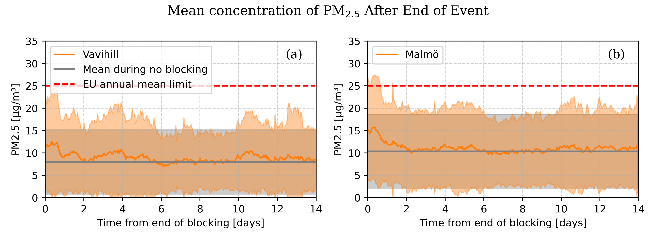
Figure 6: Mean PM2.5 concentrations in Vavihill (a) and Malmö (b) after the end of high-pressure blocking events (green line). The grey line shows the mean PM2.5 during non-high pressure blocking events. The shaded region indicates the standard deviation of the data.

3.1.1 The Change in Aerosol Concentrations Depending on Wind Direction
The blocking events was sorted in different ways to explore how the PM2.5 concentration depended on different parameters. Firstly, the data was sorted into one of four wind categories: north-east (310° to 70°), south-east (70° to 190°), west (190° to 310°), and mixed direction. This was done by categorizing the data if 50% of the wind directional data fell into one of these categories, with zero wind speed being handled as a missing value. The cases where no more than 50% of the data comes from one single direction are categorised into the mixed direction. The change in PM2.5 concentrations in Vavihill and Malmö during high-pressure blocking events for different wind directions can be seen in Figure 7. In the case of Vavihill, 7.4% of the winds came from the north-east (310° to 70°), 25.3% from the south-east (70° to 190°), 24.2% from the west (190° to 310°) and 43.% has a mixed direction. For Malmö, 8.1% of the winds came from the north-east (310° to 70°), 24.2% from the south-east (70° to 190°), 18.6% from the west (190° to 310°) and 49.1% from no specific direction. Very little data is observed from the north-east because this is a uncommon wind direction during high-pressure blocking events as seen in Figure 1. A large proportion of the data was categorized as mixed, since the high-pressure blocking are often not completely stationary and their movement result in changing wind directions.
The changes in PM2.5 concentrations with winds from different direction can be seen in Figure 7. One can observe similarities between the aerosol concentrations depending on wind directions for Vavihill and Malmö, where a larger increase can be observed in Malmö. When only considering the north-east direction, no strong increase or high levels of PM2.5 were detected, as supported by the τ-values being under 0.5 for Malmö Figure 7b, whereas for Vavihill there was not enough data to calculate an average value in Figure 7a. The southeastern wind direction display the highest PM2.5 concentrations out of all directions. In Vavihill the southeastern direction has a clear increase until day nine, where the levels suddenly drop (Figure 7c). This yielded an overall τ value of 0.41, however when calculating a τ-value for the first nine days only, it is equal to 0.68, showing a clear increase. The southeastern direction for Malmö yielded a high τ-value of 0.64 and the mean concentration, for all blocking events from the south-east, exceed the EU annual mean limit with a maximum concentration of 26 µg m−3(Figure 7d). For the western wind direction, an increase in PM2.5 can be seen in Vavihill as supported by τ = 0.57, however a drop is observed after day six (Figure 7e). The western wind direction for Malmö showed an increase until day eight, where it suddenly drops. Although elevated levels can be seen on day eight, one must note that the spread of the values is large (Figure 7f). The mixed direction in Figure 7g-h showed increases similar to the increase in Figure 5. Even when the wind direction is changing during the blocking events a monotonic increase is observed, supported by τ = 0.70 in Vavihill and τ = 0.79 in Malmö.
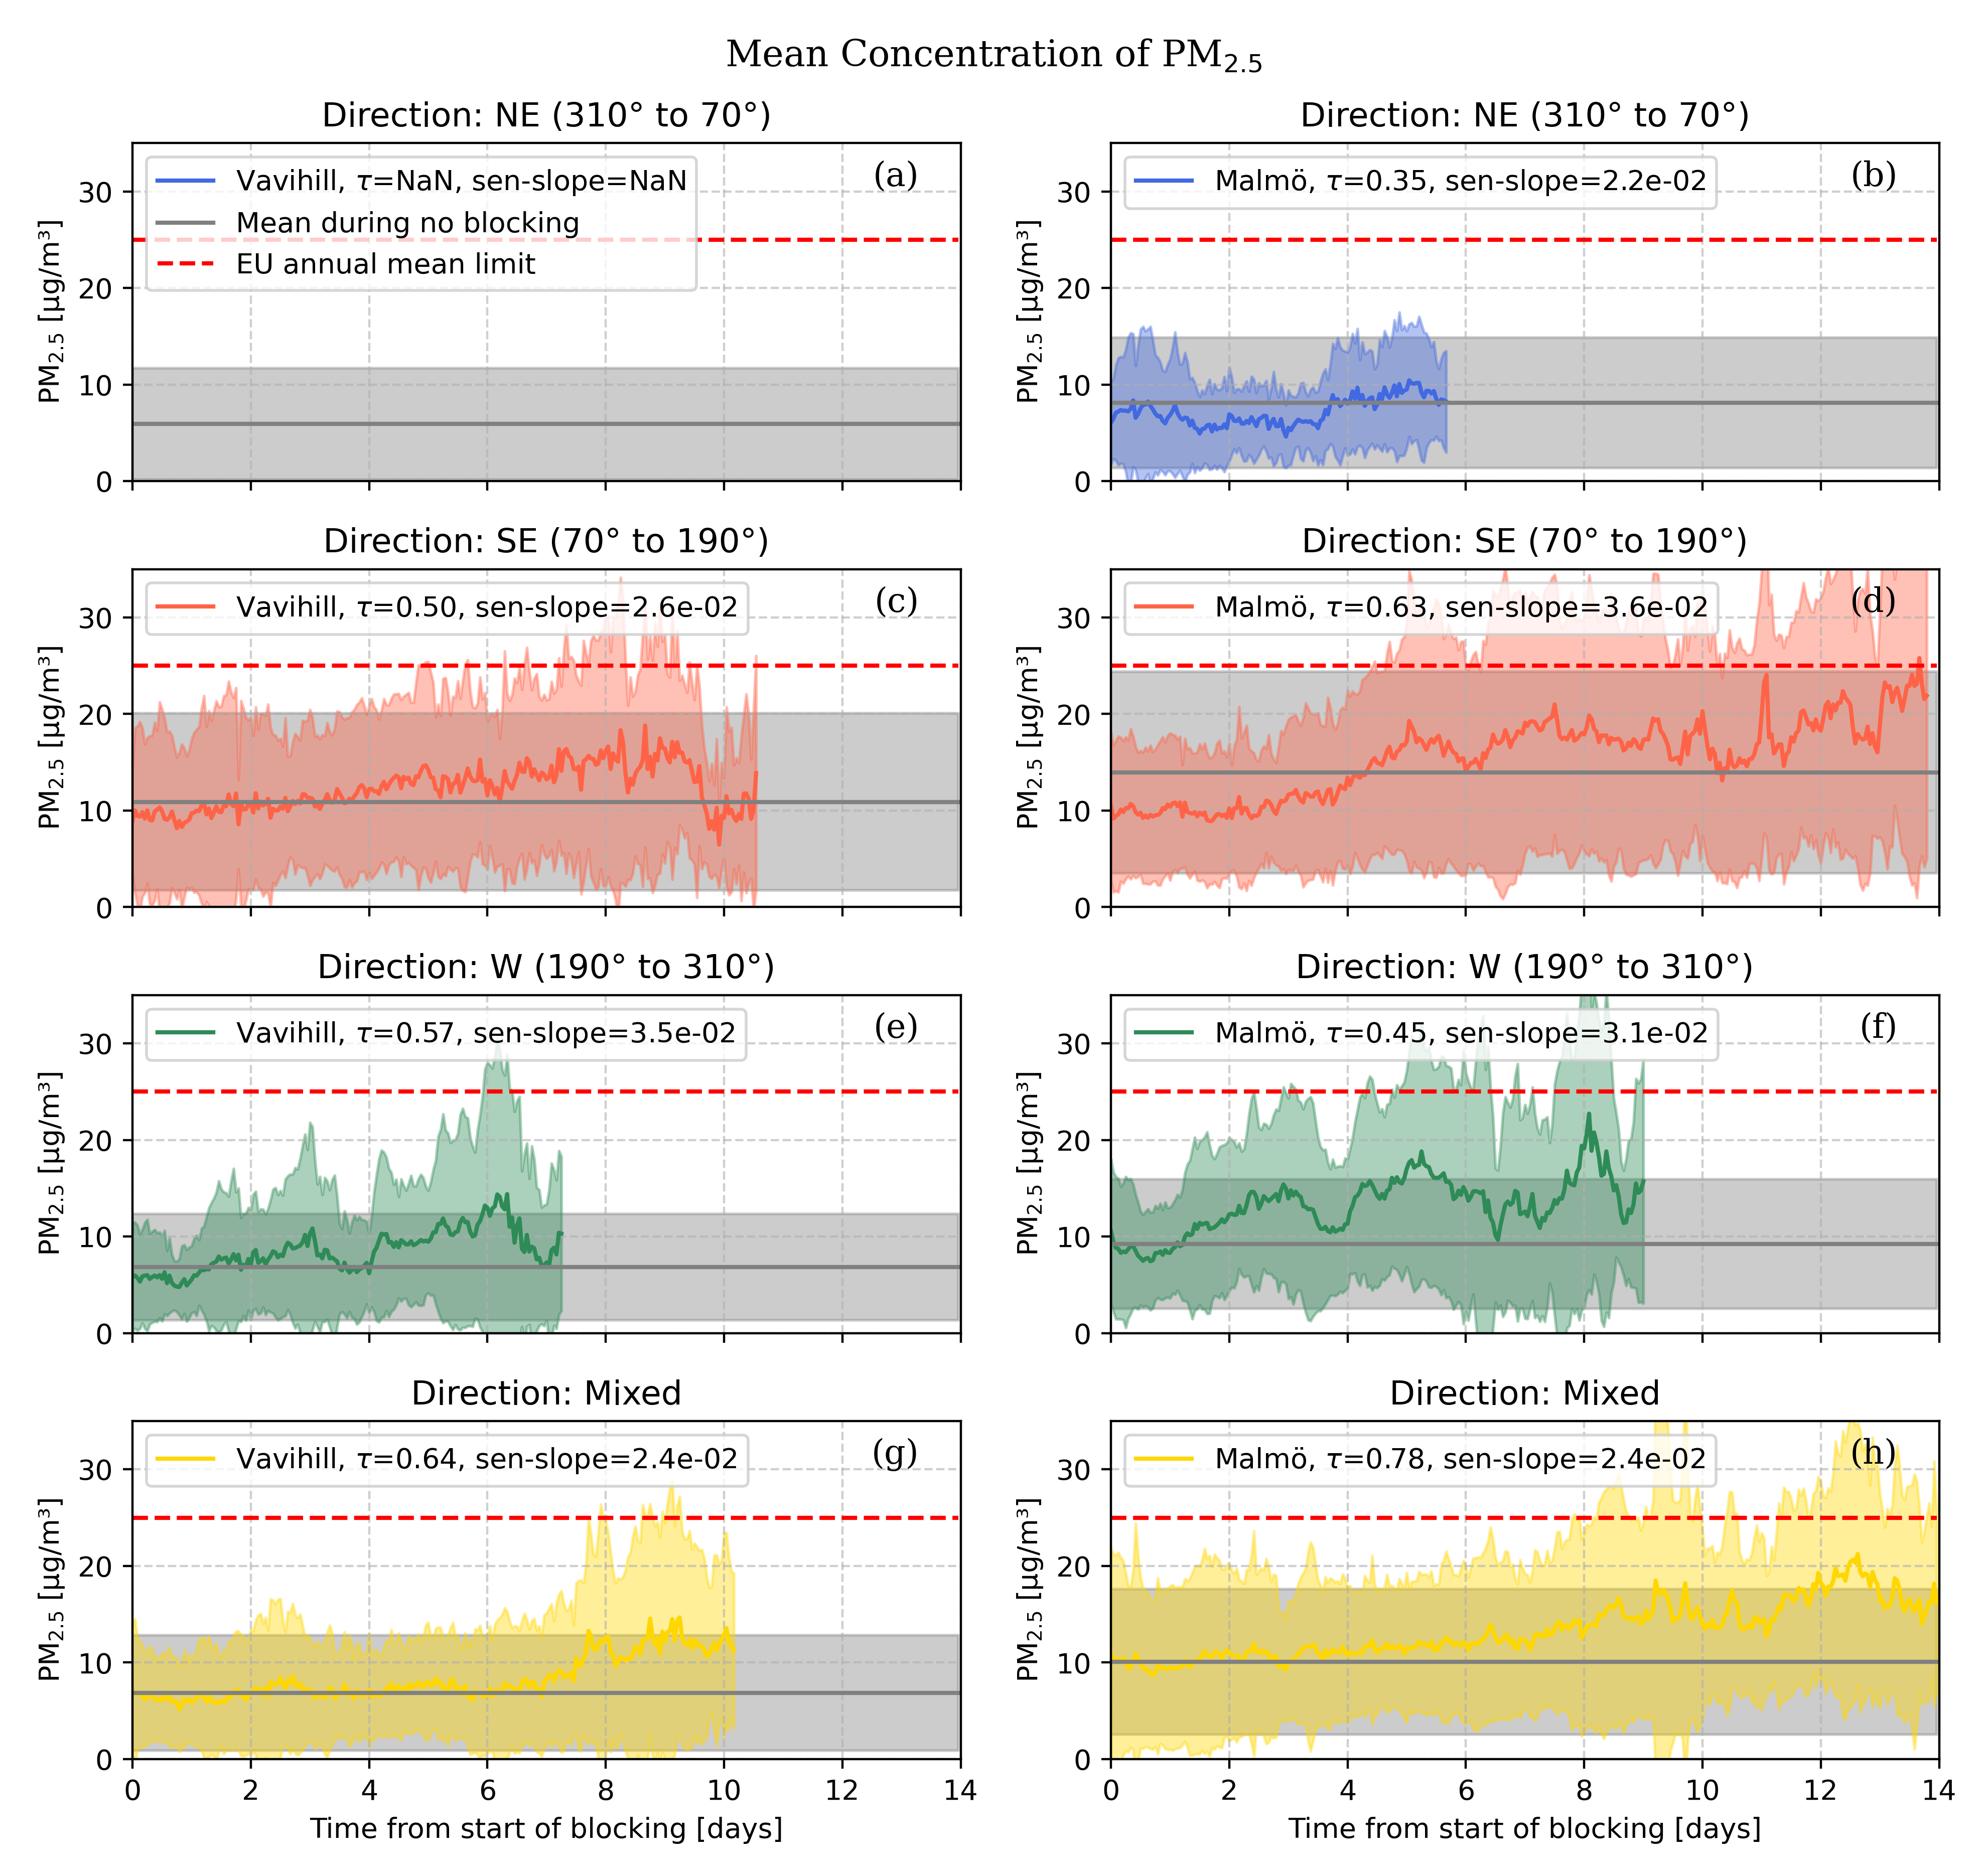
Figure 7: PM2.5 concentrations evolution in Vavihill and Malmö for different wind directions during high-pressure blocking events. This is shown by the different coloured lines and the EU annual mean limit is displayed by the red line. The mean during no high-pressure blocking event for winds from each direction is seen by as the grey line. The shaded regions indicates the standard deviation of the data. Figure (a) is empty due to insufficient amount of data for the northeastern category in Vavihill.

3.1.2 The Change in Aerosol Concentrations Depending on Season
The data has also been sorted according to the season when the blocking event occurred. The categorisation was done by taking the midpoint date of the blocking and categorizing the season by the month it occupied. December, January, and February were considered winter; March, April, and May were considered spring; June, July, and August were considered summer and September, October, and November were considered autumn. The seasonal change in concentrations of PM2.5 during high-pressure blocking events can be seen in Figure 8. 19.3% of the events occurred during the winter, 31.6% during the spring, 21.0% during the summer and 28.1% during the autumn. The highest average general concentrations (grey lines) show that the highest PM2.5 concentrations occur in winter and spring in Malmö and lower PM2.5 concentrations are observed during the summer in both locations. During the winter, an weak increase in the PM2.5 concentrations were observed in Vavihill while Malmö showing a much stronger increase which is supported by τ = 0.70 and the Sen’s slope being 6.9 × 10−2 µg m−3 d −1 (Figure 8ab). However the statistics for the winter plot in Vavihill ended 3 days before that in Malmö due to insufficient amount of events. In Malmö the average values are almost at the EU-limit level at day eight. A slight increase can be seen for the spring in both locations, with Vavihill going from 9 µg m−3 to a maximum of 12 µg m−3, and Malmö from 11 µg m−3 to a maximum of 16 µg m−3 (Figure 8c-d). There are steady increases in PM2.5 levels during summer though they start and end at much lower values than during the other seasons. A large increase can be seen during the autumn (Figure 8g-h), where high levels of PM2.5 can be observed towards the end of the period, with Vavihill going from 10 µg m−3 to a maximum of 16 µg m−3, and Malmö from 11 µg m−3 to a maximum of 26 µg m−3 .
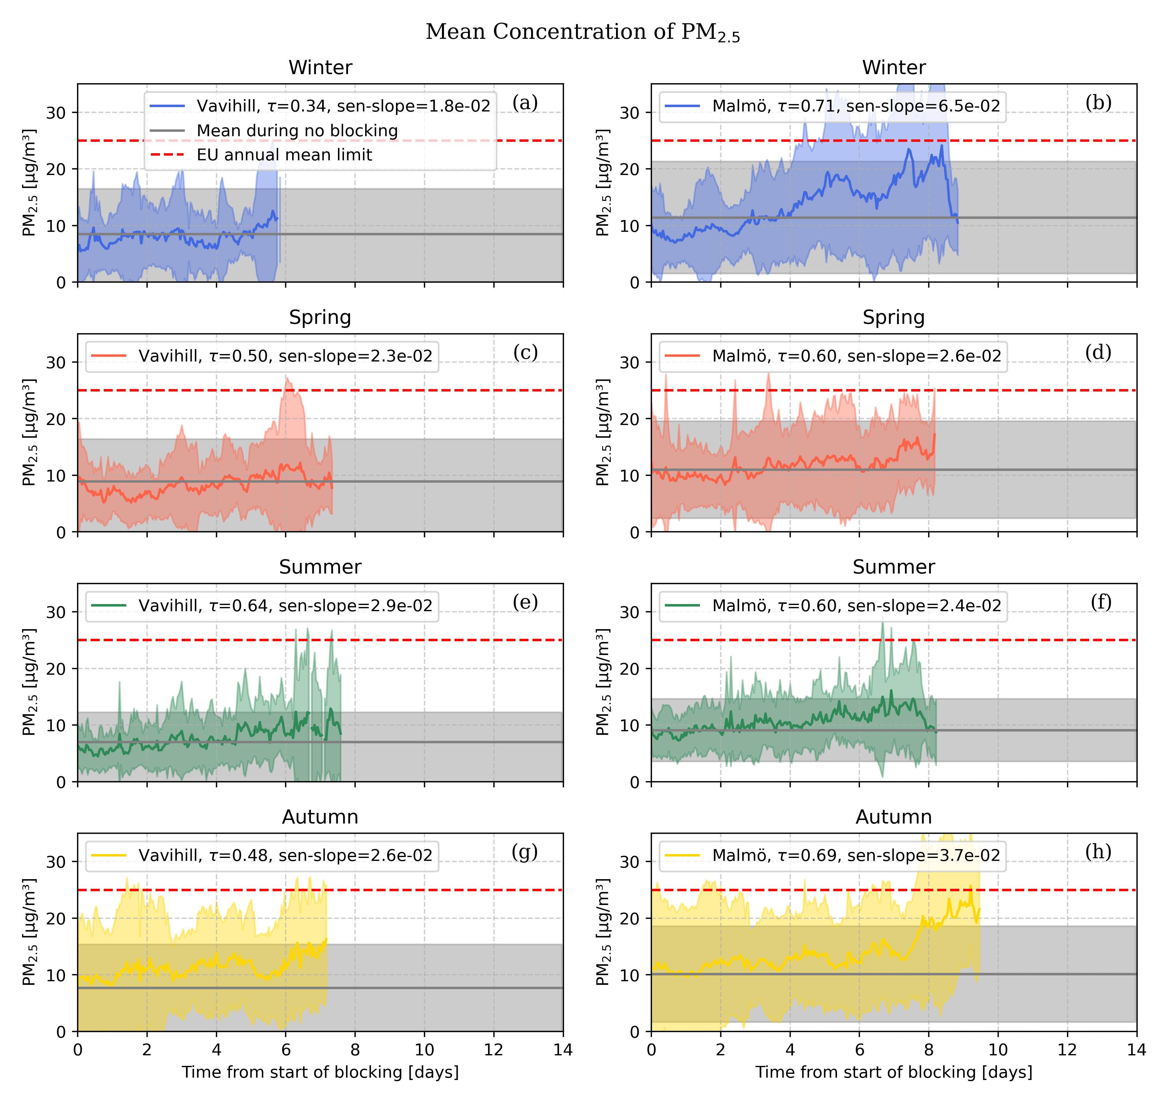
Figure 8: PM2.5 concentrations in Vavihill and Malmö during high-pressure blocking events for different seasons. This is shown by the different coloured lines and the EU annual mean limit is displayed by the red line. The mean during no high-pressure blocking event for winds from each direction is seen by as the grey line. The shaded regions indicates the standard deviation of the data.

3.1.3 The Change in Aerosol Concentrations Depending on Pressure Strength
Lastly, the data was categorized based on the strength of the high-pressure blocking, where a weak high-pressure blocking event had a mean atmospheric pressure between 1014 hPa and 1020 hPa, a medium strong event had a mean atmospheric pressure between 1020 hPa and 1025 hPa, and a stronger event had a mean atmospheric pressure over 1025 hPa. The increase in PM2.5 concentrations depending on the strength of the high-pressure blocking event can be seen in Figure 9. In the case of Vavihill, 22.1% of the blocking events occurred with a mean pressure below 1020 hPa 46.3% occurred between 1020 and 1025 hPa and 31.6% occurred with a mean pressure over 1025 hPa. In the case of Malmö, 16.8% of the blocking events occurred with a mean pressure below 1020 hPa 48.4% occurred between 1020 and 1025 hPa and 34.8% occurred with a mean pressure over 1025 hPa.
From the plots, one can observe similar behaviour for the two locations. For the weaker high-pressure blocking events no prolonged increase, nor highly elevated levels of PM2.5 in either location (Figure 9a-b). In the case of medium strong high-pressure blocking events a stronger increase in Vavihill τ = 0.62 and weaker in Malmö τ = 0.30 can be seen. When observing both plots one can see a maximum around day nine, although the maximum in Malmö has a larger value spread (Figure 9c-d). For the stronger high-pressure blocking events one can see a strong increase in the case of Malmö and in Vavihill, although the increase in Vavihill is slightly weaker. When viewing the plots Figure 9e-f one observes that the levels of PM2.5 in the case of Vavihill and Malmö exceed the normal range at day thirteen, where the mean reached the EU annual mean limit for Malmö. In Vavihill the values went from 9 µg m−3 to a maximum of 21 µg m−3, and in Malmö they went from 12 µg m−3 to a maximum of 28 µg m−3 .
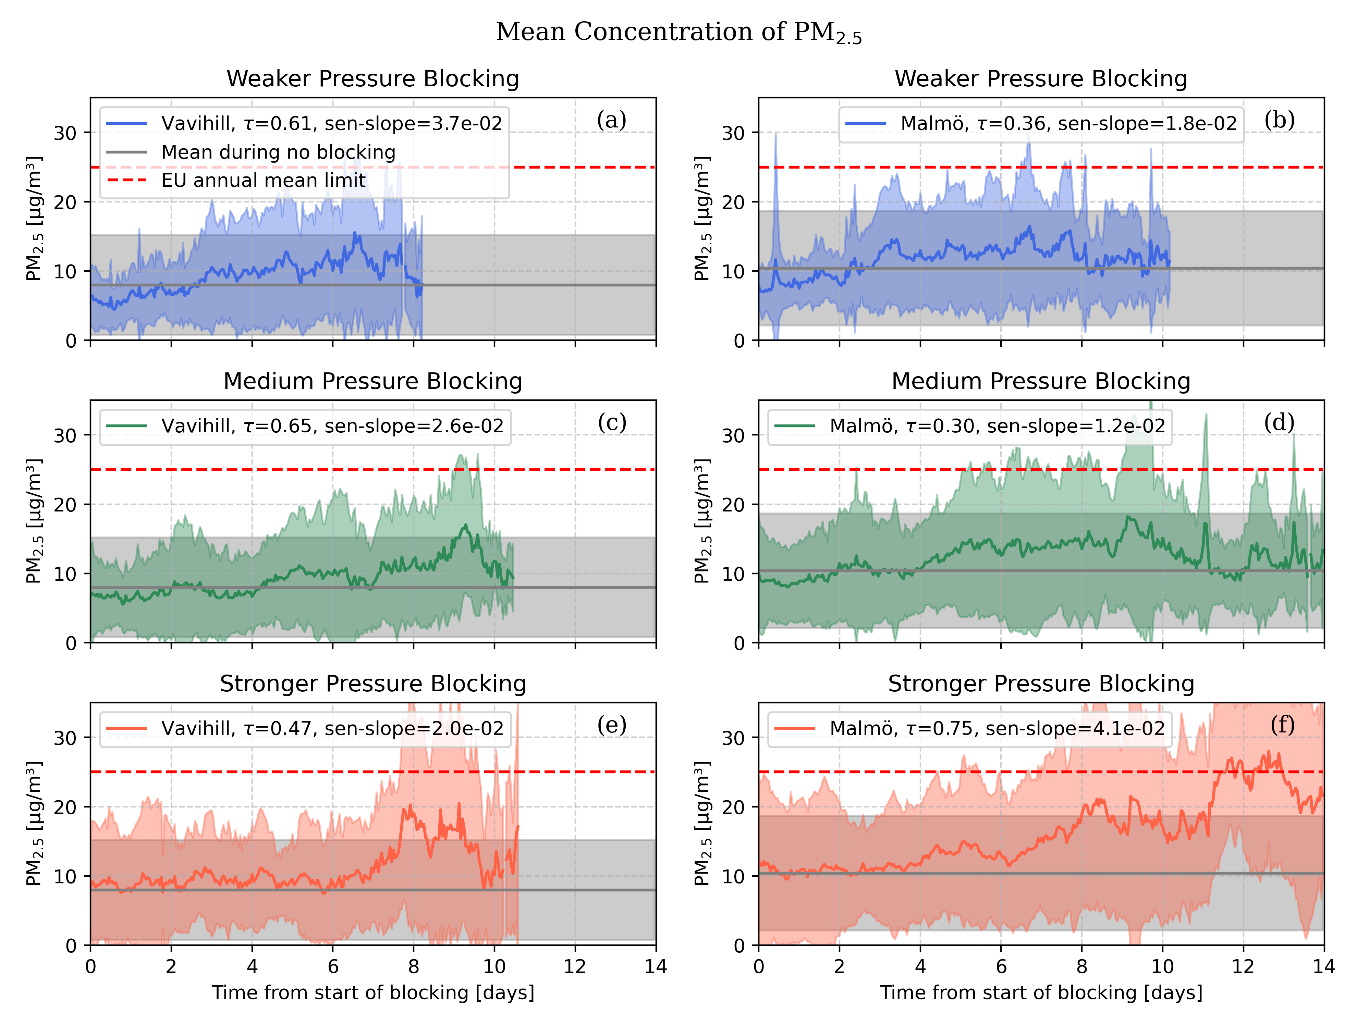
Figure 9: PM2.5 concentrations in Vavihill and Malmö for different pressure strengths during high-pressure blocking events. This is shown by the coloured lines, the mean during no high-pressure blocking event can be seen by the grey line and the EU annual mean limit is displayed by the red line. The shaded regions indicates the standard deviation of the data.

3.2 The Frequency of High-Pressure Blocking Events
The last task of this study was to evaluate whether high-pressure blocking events had become increasingly more common in southern Sweden over the past 75 years. This was evaluated in two different ways: by calculating the number of days under high-pressure blocking events per year, and the number and lengths of high-pressure blocking events per year. The number of days of blocking was also sorted by the season of the blocking to provide more insight into the nature of the high-pressure blocking events. When observing the number of high-pressure blocking events per year, no significant change in frequency could be seen (see Figure 10). Since the highest levels of PM2.5 occurred toward the end of the events (see Figure 5–9), the frequency of longer high-pressure blocking events was also examined. However, no increase could be observed in any of the cases. More interestingly, a small decrease can be observed from the τ-values and the Sen’s slope values. However, one must note that the p-values, from the Mann-Kendall test, are much larger here than in Figure 5–9
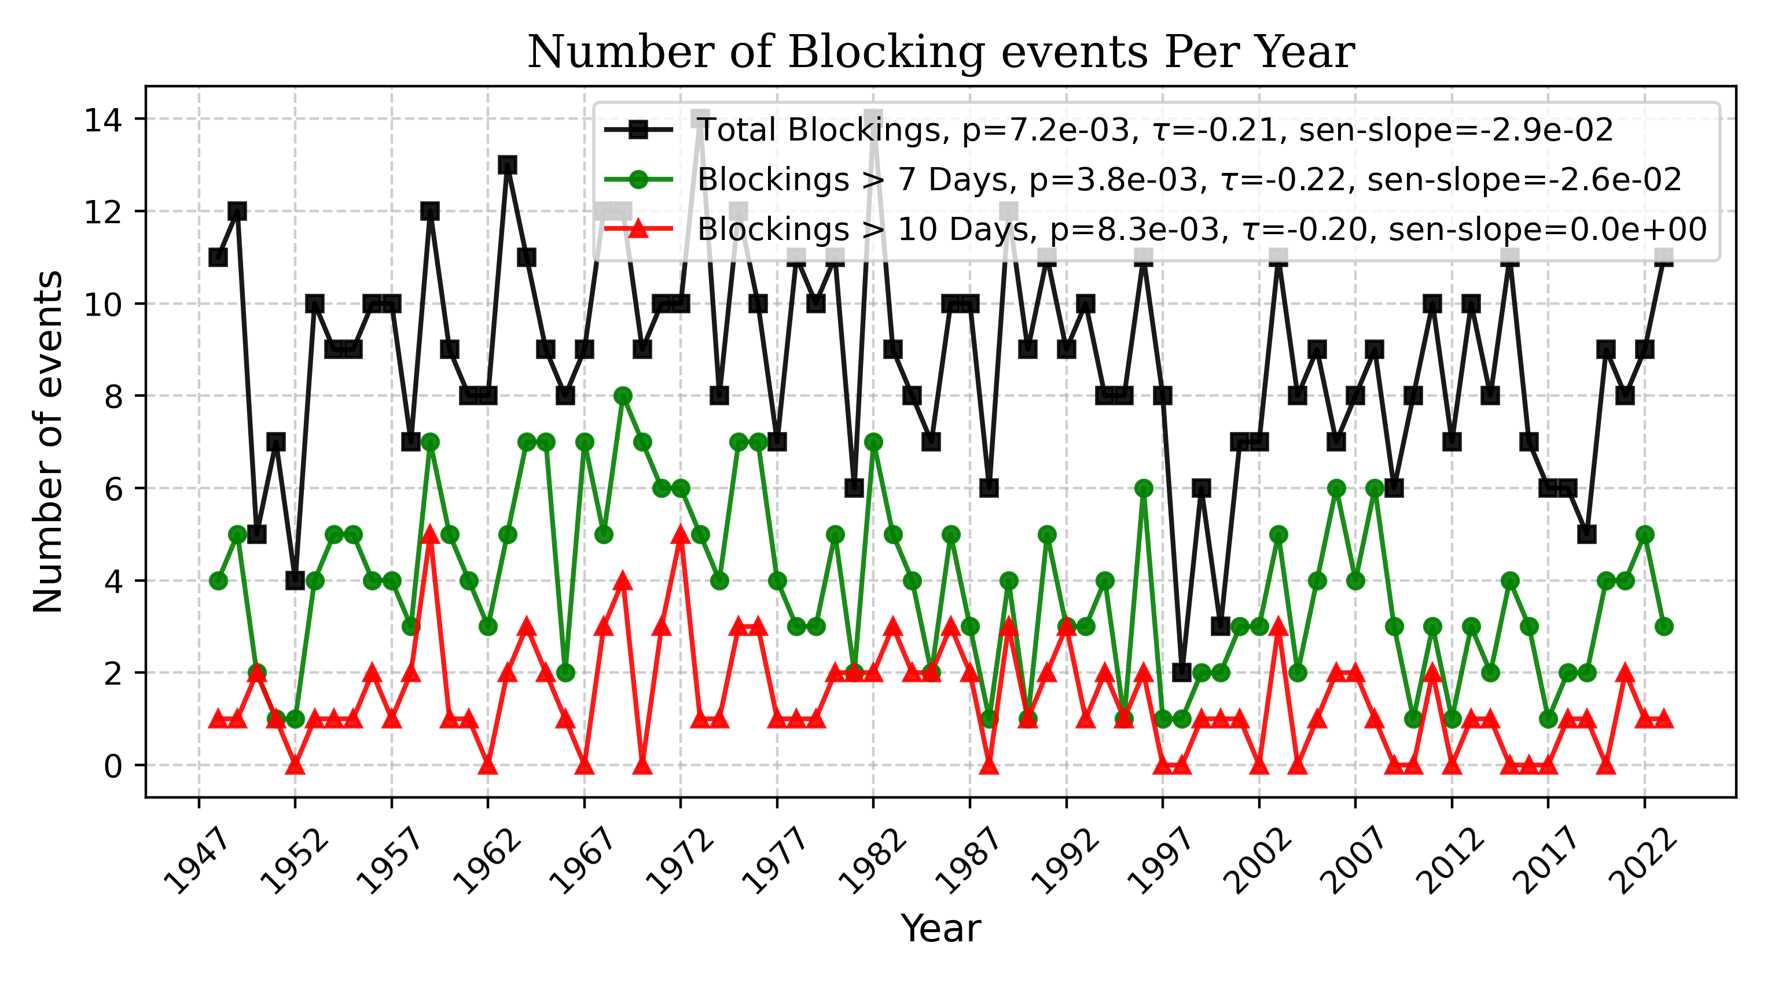
Figure 10: This plot show the change in frequency of high-pressure blocking events. The plots also indicates the change in events longer than seven and ten days.

In Figure 11, the number of days with high-pressure blocking events per year can be seen. Here, the total, wind, seasonal, and pressure strength dependence can be observed. Also here, a slight decrease can be seen in most plots, especially the total blocking days per year (l). When observing the slight decline of the frequency of the highpressure blocking events in Figure 10 and Figure 11 one must note that the low |τ|-values indicate that the trend is not monotonic. Furthermore, the large p-values in Figure 11 indicate that the trend is more random in comparison to the mean aerosol concentration plots observed in Figures 5–9. One can observe that no type of high-pressure blocking events has become more common during the last 74 years.
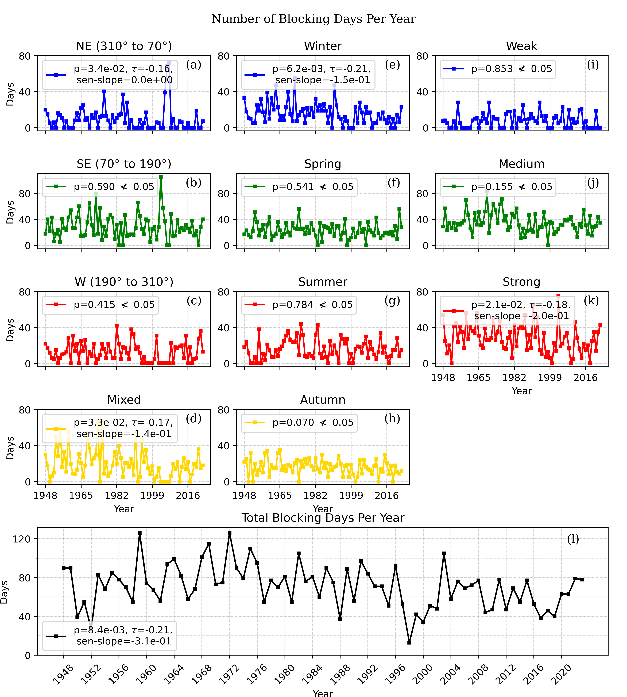
Figure 11: The number of days under a high-pressure blocking event each year, during each season, and for different pressure strengths. If the p-value was greater than 0.05, the corresponding τ-value and Sen’s slope were discarded, as the test was deemed statistically insignificant.

4 Discussion and Conclusion
From Figure 5–9 it is clear that the high elevations of PM2.5 occur after seven to thirteen days. The sudden PM2.5 drops in Figure 5–9 might be to aerosol fluctuations or the end of shorter high-pressure blocking events being removed from the statistic, however an accumulative increase is still observable. The accumulative increase of PM2.5 can be seen in Figure 5 where one can see that the combination of all the other plots resulted in a steady increase in the case of Malmö and in Vavihill. Especially strong increases with elevated PM2.5 levels could be seen with winds from the south-east and for stronger pressure high-pressure blocking events.
The European Union mean limit, 25 µg m−3, was only exceeded with winds from the south-east and high-pressure blocking events with a mean above 1025 hPa in Malmö. These two categories also yielded elevated levels in Vavihill, although they did not reach the European Union mean limit. One reason why Malmö saw higher aerosol levels could be due to more industrial activities being located in Malmö, as well as the city’s closer proximity to central Europe, meaning that the stagnant air during the high-pressure blocking event affected Malmö more. Another argument for why a larger increase was seen in Malmö than in Vavihill could be the difference in thermal inversions. Vavihill is located in a rural area with abundant greenery and canopy cover, which would reduce the strength of the inversion, whereas the impervious surfaces in Malmö would enhance it. Since thermal inversion is essential for increased aerosol levels, this effect would certainly have an impact on the different locations and could help explain the difference in PM2.5 concentrations.
The finding that winds from the south-east increased aerosol levels more than any other direction suggests that long-range advection plays a crucial role in the accumulation of aerosols in the region. The reason why a stronger mean pressure induced a more pronounced aerosol increase could be explained by the stronger pressure being a consequence of an intensified high-pressure blocking event. This would amplify the thermal inversion and also result in more pronounced anticyclonic winds. However, the difference between advection and local emissions should be further researched, to investigate the main contributor to the rise in aerosol levels.
The observation that no type of high-pressure blocking event had become increasable more frequent during the last 74 years is an interesting results. One could discuss if this opposes the findings from Lupo 2020 who saw an increase during the last 50 years. However those observations was on the entire Northern Hemisphere, whereas these are on a specific location. Furthermore the European centred observation in Fahimi et al. 2020 showed an decrease in high-pressure blocking events between 1959 to 1988, and an increased from 1989 to 2011, which is more aligned with the findings in this study. Observing Figure 11 and Figure 10l the decrease is more prominent between 1948 to 1998, and a small increase can be observed from 1998 to 2023. Therefore, the results in this study does not oppose the result from other studies on the subject.
This study has demonstrated that the presence of high-pressure blocking events in southern Sweden significantly increased the aerosol concentration in both rural and urban locations. The mean PM2.5 in Malmö went from 10 µg m−3 to a maximum of 21 µg m−3 during the high-pressure blocking event, and an increase from 7 µg m−3 to a maximum of 18 µg m−3 could be observed in Vavihill during the event. Increased levels of PM2.5 were seen in both locations after eight to thirteen days of uninterrupted high-pressure blocking, indicating accumulation of aerosols during the events. This accumulation was mainly attributed to the presence of a subsidence inversion layer, which prohibits vertical air mixing. However, it was also observed that once the high-pressure blocking event subsided, aerosol levels returned to normal within a day. A stronger increase was found in the urban area of Malmö than the rural area of Vavihill, which was mainly attributed to local emissions and possibly a slightly stronger ground inversion, especially during the winter. The wind directional dependence on PM2.5 concentrations indicated that the long-range advection of aerosols was a significant contributor to aerosol concentration in the region, where winds from central and eastern Europe significantly increased the aerosol levels. The seasonal dependence indicated an increase during the winter. A stronger increase was also observed with stronger high-pressure blocking events, where the highest levels of PM2.5 could be observed. Observing the lengths and number of high-pressure blocking events showed that there has not been an increase of any sort during the last 74 years, which aligns with other European studies.
The analysis of aerosol concentrations during meteorological events is important for monitoring the health risks associated with different meteorological phenomena. This thesis has shown that not only domestic emissions play a role in air quality, but that advection from nearby countries also plays a crucial role. This shows the magnitude of international work to prohibit the large-scale emissions of aerosols. As the climate changes, so does the weather, and understanding how these changes affect us is of utmost importance.

References
Analitis, A. et al. (2014). “Effects of Heat Waves on Mortality: Effect Modification and Confounding by Air Pollutants”. In: Epidemiology 25.1, pp. 15–22. DOI: 10.1097/EDE.0b013e31828ac01b.
Bartholy, Judit, Rita Pongracz, and Margit Pattantyús-Ábrahám (2006). “European Cyclone Track Analysis Based on ECMWF ERA-40 Data Sets”. In: International Journal of Climatology 26.11, pp. 1517–1527. DOI: 10 .1002/joc.1392.
Cai, Wenyue et al. (2020). “Impact of “Blocking” Structure in the Troposphere on the Wintertime Persistent Heavy Air Pollution in Northern China”. In: Science of The Total Environment 741, p. 140325. ISSN: 0048-9697. DOI: 10.1016/j.scitotenv.2020.140325.
Crétat, Julien et al. (Mar. 2024). “Impact of Topography and Land Cover on Air Temperature Space-Time Variability in an Urban Environment with Contrasted Topography (Dijon, France, 2014–2021)”. In: Theoretical and Applied Climatology 155.3, pp. 1941–1958. ISSN: 1434-4483. DOI: 10.1007/s00704-023-04742-4. (Visited on 07/21/2025).
Dempsey, Frank (June 2018). “A Survey of Regional-Scale Blocking Patterns and Effects on Air Quality in Ontario, Canada”. In: Atmosphere 9.6, p. 226. ISSN: 2073-4433. DOI: 10.3390/atmos9060226. (Visited on 07/11/2025).
E. Frohne (Jan. 2009). Location Map of Skåne County in Sweden. Skåne.
European Environment Agency (2024). Europe’s Air Quality Status 2024. https://www.eea.europa.eu/publications/europesair-quality-status-2024. (Visited on 03/09/2025).
Fahimi, Sara et al. (Mar. 2020). “Study of the Climatological Behaviors of Euro-Atlantic and West Asia Blockings in the Period of 1959–2018”. In: Dynamics of Atmospheres and Oceans 89, p. 101130. ISSN: 0377-0265. DOI: 10.1016/j.dynatmoce.2020.101130. (Visited on 07/17/2025).
Gramsch, E. et al. (Dec. 2014). “Influence of Surface and Subsidence Thermal Inversion on PM2.5 and Black Carbon Concentration”. In: Atmospheric Environment 98, pp. 290–298. ISSN: 1352-2310. DOI: 10.1016/j. atmosenv.2014.08.066. (Visited on 04/14/2025).
Greg O’Hare, Rob Wilby, and John Sweeney and Rob Wilby (2005). Weather, Climate and Climate Change. England: Pearson Eductaion Limited. ISBN: 0130 283193.
Hussain, Md. and Mahmud, Ishtiak (July 2019). “pyMannKendall: A Python Package for Non Parametric Mann Kendall Family of Trend Tests.” In: Journal of Open Source Software. 1556th ser. 4.3, p. 1556. ISSN: 2475-9066. DOI: 10.21105/joss.01556.
Hvidtfeldt, Ulla Arthur et al. (Feb. 2019). “Long-Term Residential Exposure to PM2.5, PM10, Black Carbon, NO2, and Ozone and Mortality in a Danish Cohort”. In: Environment International 123, pp. 265–272. ISSN: 0160-4120. DOI: 10.1016/j.envint.2018.12.010. (Visited on 04/14/2025).
Lautrup, Benny (2011). Physics of Continuous Matter: Exotic and Everyday Phenomena in the Macroscopic World. 2nd ed. eBook edition. Boca Raton, FL: CRC Press. ISBN: 978-1-4398-9420-0.
Luo, Dehai, Yao Yao, and Aiguo Dai (Mar. 2015). “Decadal Relationship between European Blocking and the North Atlantic Oscillation during 1978–2011. Part I: Atlantic Conditions”. In: DOI: 10.1175/JAS- D- 14- 0039.1. (Visited on 07/17/2025).
Lupo, Anthony R. (Dec. 2020). Atmospheric Blocking Events: A Review. https://doi.org/10.1111/nyas.14557. (Visited on 03/09/2025).
Messori, Gabriele et al. (Jan. 2018). “The Impact of Future Atmospheric Circulation Changes over the EuroAtlantic Sector on Urban PM2.5 Concentrations”. In: Tellus B: Chemical and Physical Meteorology 70.1. ISSN: 0280-6509. (Visited on 07/16/2025).
Mitchell, John F. B. et al. (2006). “Extreme Events Due to Human-Induced Climate Change”. In: Philosophical Transactions of the Royal Society A: Mathematical, Physical and Engineering Sciences 364.1845, pp. 2117–2133. DOI: 10.1098/rsta.2006.1816.
Özdemir, Emrah Tuncay, Enes Birinci, and Ali Deniz (July 2024). “Multi-Source Observations on the Effect of Atmospheric Blocking on Air Quality in ˙Istanbul: A Study Case”. In: Environmental Monitoring and Assessment 196.8, p. 698. ISSN: 1573-2959. DOI: 10.1007/s10661-024-12873-y. (Visited on 07/10/2025).
Por˛ebska, Magdalena and Małgorzata Zdunek (2013). “Analysis of Extreme Temperature Events in Central Europe Related to High Pressure Blocking Situations in 2001–2011”. In: Meteorologische Zeitschrift 22.5, pp. 533–540. ISSN: 0941-2948. DOI: 10.1127/0941-2948/2013/0455.
Region Skåne (2025). Skåne, Sweden – Map. Accessed: 2025-07-16. URL: https://www.skane.com.
Sellergren, Jessika (2025). “Photographs shared via personal communication”. Received from Jessika Sellergren, July 2025.
Sharma, Shubham, Mina Chandra, and Sri Harsha Kota (2020). “Health Effects Associated with PM2.5: A Systematic Review”. In: Current Pollution Reports 6.4, pp. 345–367. ISSN: 2198-6592. DOI: 10.1007/s40726- 020-00155-3. (Visited on 03/09/2025).
Shin, Uju et al. (Feb. 2021). “Predictability of PM2.5 in Seoul Based on Atmospheric Blocking Forecasts Using the NCEP Global Forecast System”. In: Atmospheric Environment 246, p. 118141. ISSN: 13522310. DOI: 10.1016/j.atmosenv.2020.118141. (Visited on 07/10/2025).
Sigler, Marian (Feb. 2007). Blank Map of Europe (with Disputed Regions). https://commons.wikimedia.org/wiki/File:Blank_map_of_(Visited on 05/08/2025).
Spiridonov, Vlado and Curi ´ c Mladjen (Nov. 2020). ´ Cyclones and Anticyclones | SpringerLink. https://link.springer.com/chapter/10.103-030-52655-9_17. (Visited on 03/09/2025).

